[[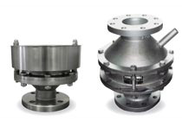](http://www.fncitalia.it/pages/flame_arresters.asp) [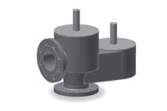](http://www.fncitalia.it/pages/breather_valves_1.asp) [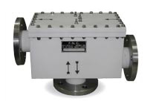](http://www.fncitalia.it/pages/breather_valves_2.asp)  
Flame and detonation arresters Breather valves Breather valves TFE lined](http://www.fncitalia.it/pages/flame_arresters.asp)[[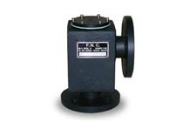](http://www.fncitalia.it/pages/pressure_relief_valves.asp) [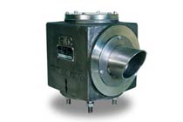](http://www.fncitalia.it/pages/vacuum_relief_valves.asp) [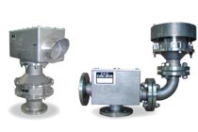](http://www.fncitalia.it/pages/vent_flame_arrester.asp)  
Pressure relief valves Vacuum relief valves Vent-line / In-line flame arresters](http://www.fncitalia.it/pages/pressure_relief_valves.asp)[[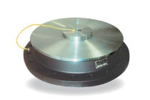](http://www.fncitalia.it/pages/emergency_vents.asp) [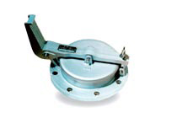](http://www.fncitalia.it/pages/gauge_hatches.asp)http://www.fncitalia.it/img/structure/logo.gif  
Emergency vents Gauge hatches](http://www.fncitalia.it/pages/emergency_vents.asp)